select * from pizza_sales

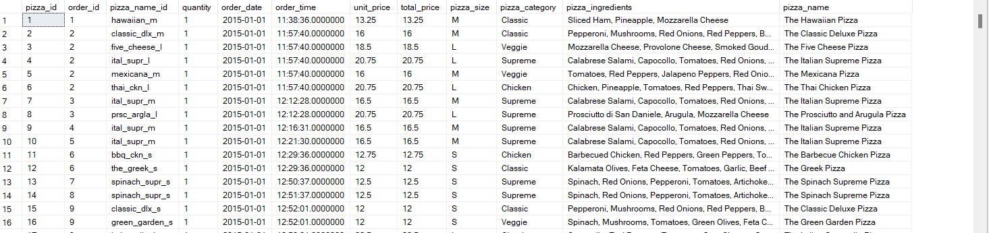

select SUM(total_price) as total_revenue from pizza_sales



select SUM(total_price)/COUNT(distinct order_id) as Avg_Order_Value

from pizza_sales



select SUM(quantity) as Total_Pizza_Sold

from pizza_sales



select Count(distinct order_id) as Total_Orders_Placed

from pizza_sales



select SUM(quantity)/Count(distinct order_id) as Avg_Pizza_Per_Order

from pizza_sales



select CAST(CAST(SUM(quantity) AS decimal(10,2))/CAST(Count(distinct order_id) as decimal(10,2)) as decimal(10,2)) as Avg_Pizza_Per_Order

from pizza_sales



-- Daily Trend For Total Orders --

select DATENAME(DW,order_date) as Order_Day , COUNT(distinct order_id ) as Total_Orders

from pizza_sales

group by DATENAME(DW,order_date)

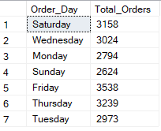

-- Monthly Trend for Total Orders

select DATENAME(MONTH, order_date) as Order_Month , COUNT(distinct order_id ) as Total_Orders

from pizza_sales

group by DATENAME(MONTH,order_date)

order by Total_Orders Desc

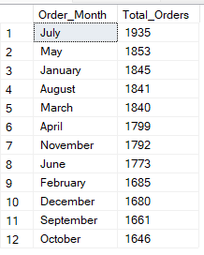

-- % of sales by pizza category --

select pizza_category ,SUM(total_price) as Total_Sales, SUM(total_price)/ (select sum(total_price) from pizza_sales) * 100 as Sales_Per_Category

from pizza_sales

group by pizza_category

order by Sales_Per_Category Desc

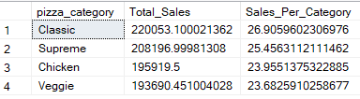

-- For January --

select pizza_category ,SUM(total_price) as Total_Sales, SUM(total_price)/

(select sum(total_price) from pizza_sales where Month(order_date) = 1) * 100 as Sales_Per_Category

from pizza_sales

where Month(order_date) = 1

group by pizza_category

order by Sales_Per_Category Desc

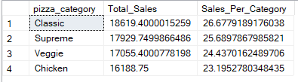

-- % of sales by pizza size --

select pizza_size ,CAST(SUM(total_price) as decimal(10,2)) as Total_Sales, CAST(SUM(total_price)/

(select sum(total_price) from pizza_sales ) * 100 as decimal(10,2)) as Sales_Per_Size

from pizza_sales

group by pizza_size

order by Sales_Per_Size Desc

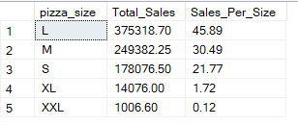

-- for 1st quarter

select pizza_size ,CAST(SUM(total_price) as decimal(10,2)) as Total_Sales, CAST(SUM(total_price)/

(select sum(total_price) from pizza_sales where DATEPART(quarter,order_date)=1 ) * 100 as decimal(10,2)) as Sales_Per_Size_By_Quarter1

from pizza_sales

where DATEPART(quarter,order_date)=1

group by pizza_size

order by Sales_Per_Size_By_Quarter1 Desc

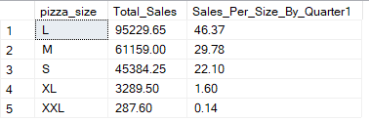

-- Top 5 and Bottom 5 sellers by revenue,total quantity , total orders --

select top 5 pizza_name , sum(total_price) as Tot_Revenue

from pizza_sales

group by pizza_name

order by Tot_Revenue Desc

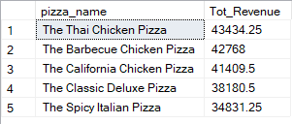

select top 5 pizza_name , sum(total_price) as Tot_Revenue

from pizza_sales

group by pizza_name

order by Tot_Revenue Asc

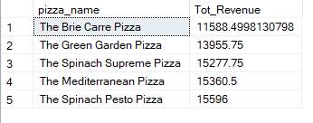

select top 5 pizza_name , sum(quantity) as Tot_Quantity

from pizza_sales

group by pizza_name

order by Tot_Quantity Desc

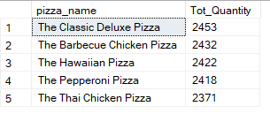

select top 5 pizza_name , sum(quantity) as Tot_Quantity

from pizza_sales

group by pizza_name

order by Tot_Quantity Asc

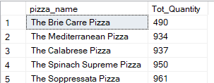

select top 5 pizza_name , count(distinct order_id) as Tot_Orders

from pizza_sales

group by pizza_name

order by Tot_Orders Desc

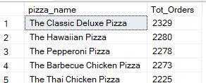

select top 5 pizza_name , count(distinct order_id) as Tot_Orders

from pizza_sales

group by pizza_name

order by Tot_Orders Asc

